

**通山县“一业一证”申办**

**操作指南**

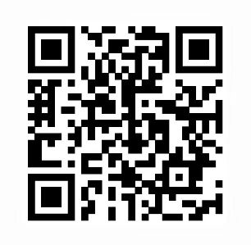

**微信扫一扫查看操作指南**